**Experiment1.2**

**Student Name: Nabha Varshney UID: 20BCS4995**

**Branch: CSE Section/Group: 20BCS_DM_704/A**

**Semester: 6th Date of Performance: 20/02/2023**

**Subject Name: MAD LAB Subject Code: 20CSP-356**

**Aim:** To design an android application to display Hello World.

**Objective:** To design an android application to display Hello World.

**Script and Output:**

* 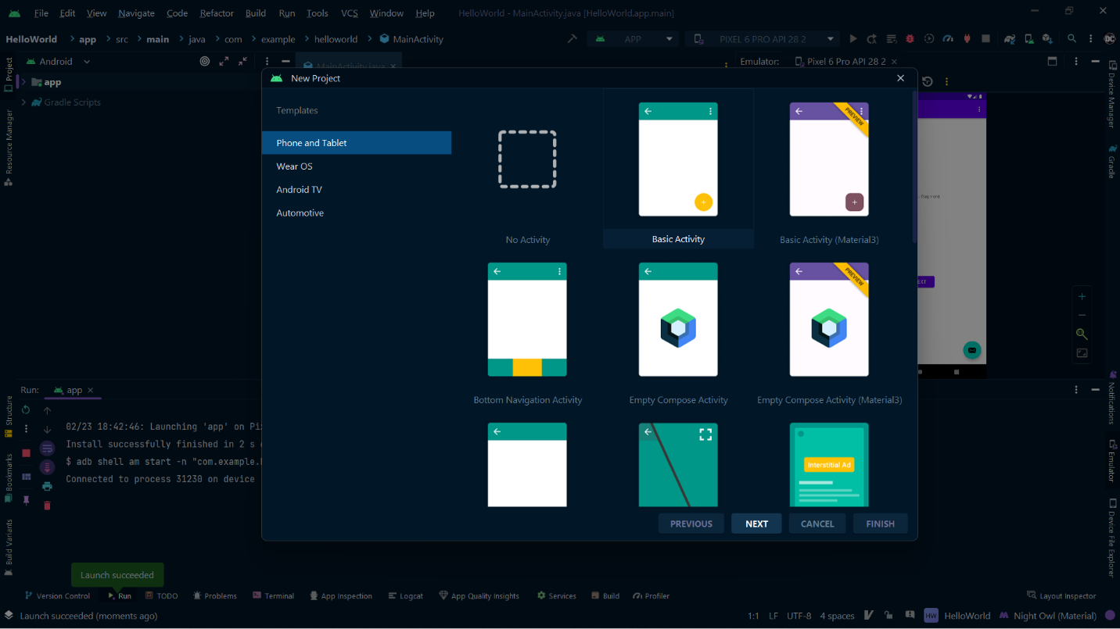First step is to create a simple Android Application using Android studio. When you click on Android studio icon, it will show screen as shown below.

You can start your application development by calling start a new android studio project. in a new installation frame should ask Application name, package information and location of the project.−

* Configure the Hello World Project Details We'll finish creating the project by configuring some details about its name, location, and the API version it.
* Change the name of the application. Change the default **Project location**to your preferred directory or just leave it as the default location.

On the **minimum API level**, ensure that **API 24: Android 7.0 Nougat**is set as the Minimum SDK. This ensures that your application runs on almost all devices.

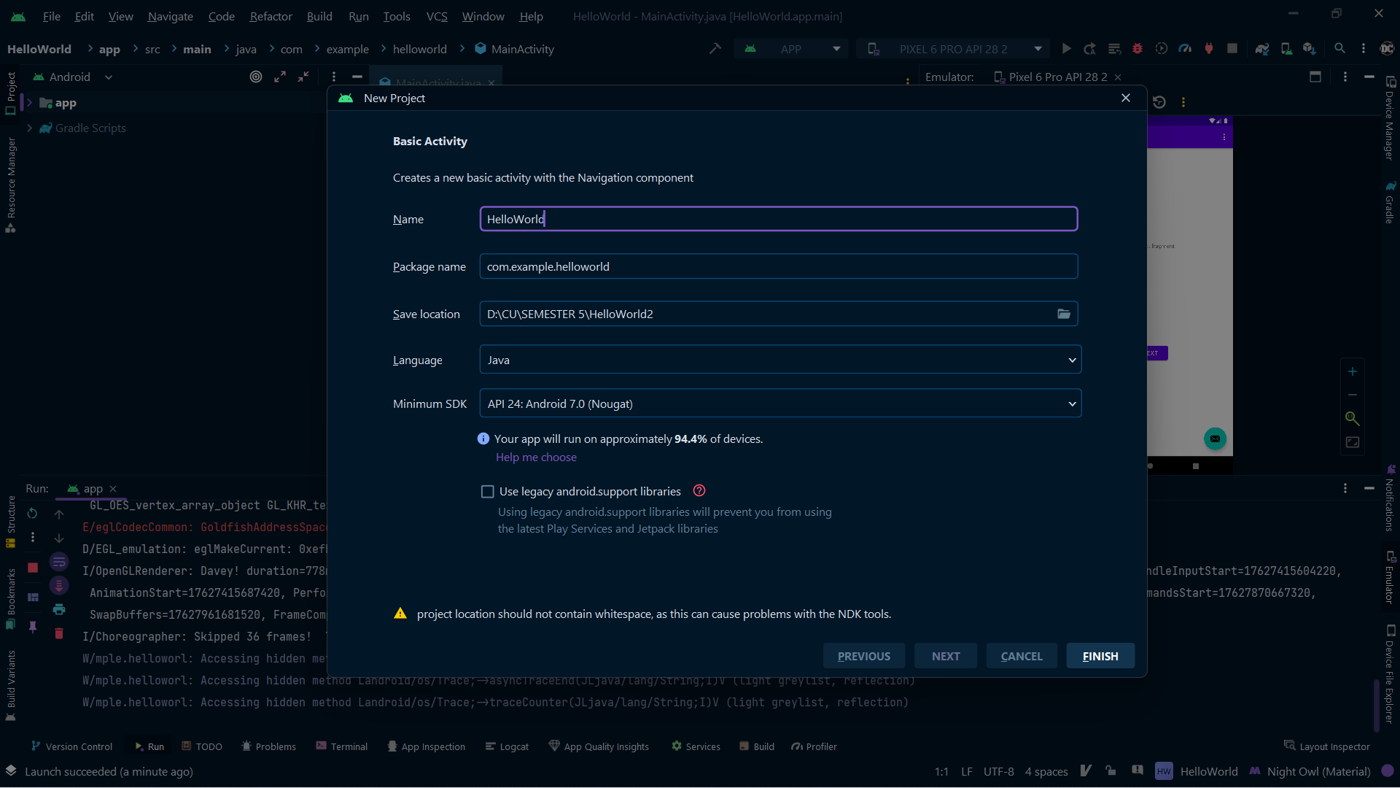

**SOURCE CODE :**

**The Main Activity File**

package com.example.helloworld;  
  
import androidx.appcompat.app.AppCompatActivity;  
  
import android.os.Bundle;  
  
public class MainActivity extends AppCompatActivity {  
  
 @Override  
 protected void onCreate(Bundle savedInstanceState) {  
 super.onCreate(savedInstanceState);  
 setContentView(R.layout.activity_main);  
 }  
}

The Layout File

The **activity_main.xml**is a layout file available in res/layout directory, that is referenced by your application when building its interface. You will modify this file very frequently to change the layout of your application. For your "Hello World!" application, this file will have following content related to default layout −

<?*xml version*="1.0" *encoding*="utf-8"?>  
<androidx.constraintlayout.widget.ConstraintLayout *xmlns:android*="http://schemas.android.com/apk/res/android"  
 *xmlns:app*="http://schemas.android.com/apk/res-auto"  
 *xmlns:tools*="http://schemas.android.com/tools"  
 *android:layout_width*="match_parent"  
 *android:layout_height*="match_parent"  
 *tools:context*=".MainActivity">  
  
 <TextView  
 *android:layout_width*="wrap_content"  
 *android:layout_height*="wrap_content"  
 *android:text*="Hello World!"  
 *app:layout_constraintBottom_toBottomOf*="parent"  
 *app:layout_constraintEnd_toEndOf*="parent"  
 *app:layout_constraintStart_toStartOf*="parent"  
 *app:layout_constraintTop_toTopOf*="parent" />  
  
</androidx.constraintlayout.widget.ConstraintLayout>

### **Running your App**

Running app on Emulator(AVD)

To run the app from Android studio, open one of your project's activity files and click Run  icon from the tool bar. Android studio installs the app on your AVD and starts it and if everything is fine with your set-up and application, it will display following Emulator window −Once Gradle finishes building, Android Studio should install the app on your connected device and start it.

